Problem 1:(Fault occurs in BUS 3)
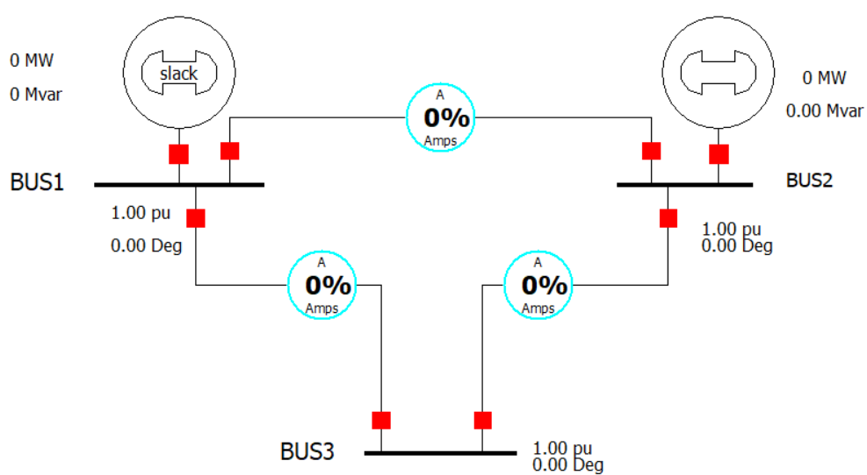
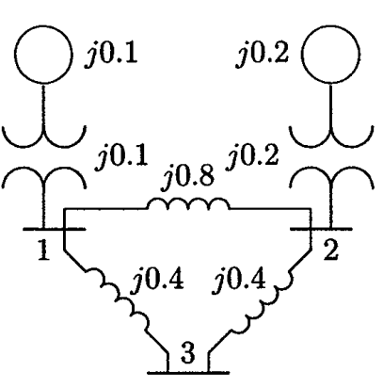

Figuer1: Fault Analysis problem 1
# Determine the fault current, the bus voltages, the bus voltages, and the line currents during the fault when a balanced three-phase fault with a fault impedance Zf=0.16 per unit occurs on.
Experimental data table:
At Z_{f} = 0.0 ohm
Number | Name | Phase Volt A | Phase Volt B | Phase Volt C | Phase Ang A | Phase Ang B | Phase Ang C
1 | BUS1 | 0.65723 | 0.65723 | 0.65723 | 2.06 | -117.94 | 122.06
2 | BUS2 | 0.62017 | 0.62017 | 0.62017 | 15.49 | -104.51 | 135.49
3 | BUS3 | 0 | 0 | 0 | 90 | 90 | 90

At Z_{f} =0.16 ohm
Number | Name | Phase Volt A | Phase Volt B | Phase Volt C | Phase Ang A | Phase Ang B | Phase Ang C
1 | BUS1 | 0.77333 | 0.77333 | 0.77333 | 2.02 | -117.98 | 122.02
2 | BUS2 | 0.74856 | 0.74856 | 0.74856 | 9.5 | -110.5 | 129.5
3 | BUS3 | 0.33748 | 0.33748 | 0.33748 | 5.7 | -114.3 | 125.7

Fault Current,Subtransient phase Current(p.u,deg):
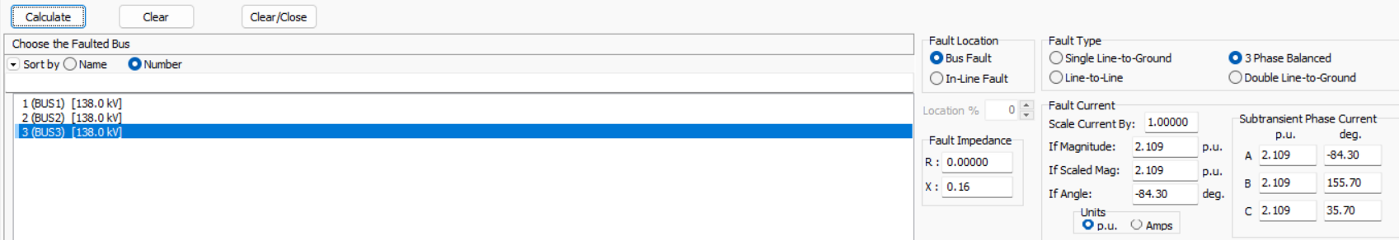

Problem 2:(Fault occurs in BUS 3)
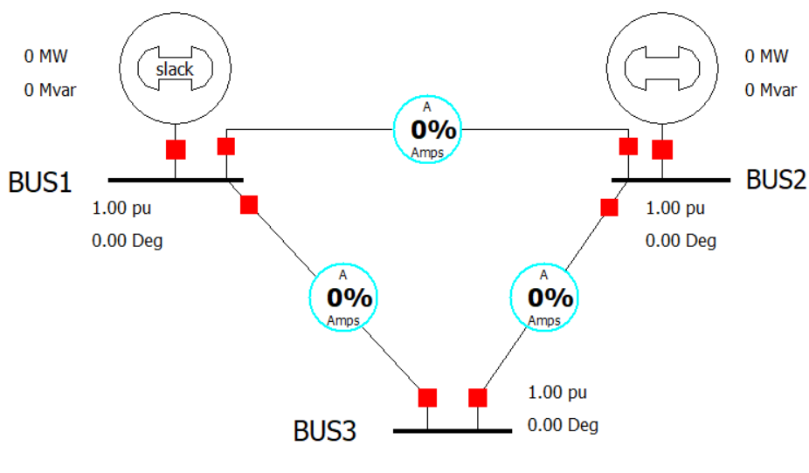
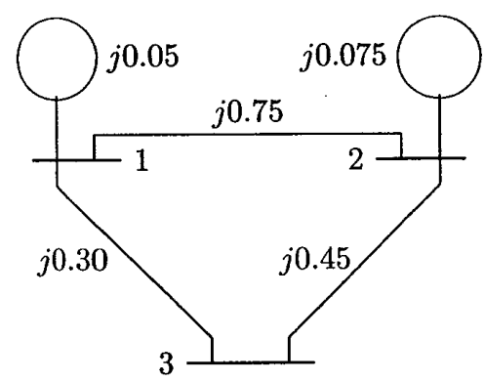

Figuer 2: Fault Analysis problem 2
# Determine the fault current, the bus voltages, the bus voltages, and the line currents during the fault when a balanced three-phase fault with a fault impedance Zf=0.19 per unit occurs on.
Experimental data table:
At Z_{f} = 0.0 ohm
Number | Name | Phase Volt A | Phase Volt B | Phase Volt C | Phase Ang A | Phase Ang B | Phase Ang C
1 | BUS1 | 0.75 | 0.75 | 0.75 | 0 | -120 | 120
2 | BUS2 | 0.75 | 0.75 | 0.75 | 0 | -120 | 120
3 | BUS3 | 0 | 0 | 0 | 90 | 90 | 90

At Z_{f} = 0.19 ohm
Number | Name | Phase Volt A | Phase Volt B | Phase Volt C | Phase Ang A | Phase Ang B | Phase Ang C
1 | BUS1 | 0.86047 | 0.86047 | 0.86047 | 0 | -120 | 120
2 | BUS2 | 0.86047 | 0.86047 | 0.86047 | 0 | -120 | 120
3 | BUS3 | 0.44186 | 0.44186 | 0.44186 | 0 | -120 | 120

Fault Current, Subtransient phase Current(p.u,deg):

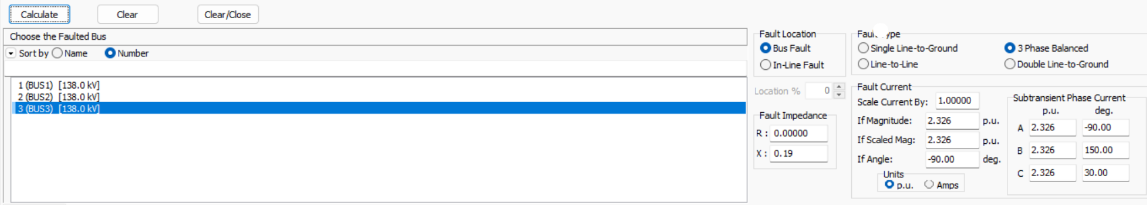

Problem 3:(Fault occurs in BUS 4)
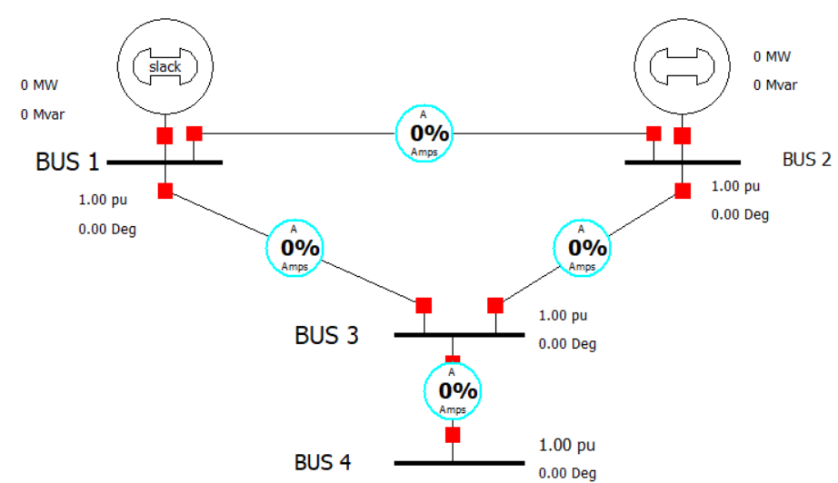
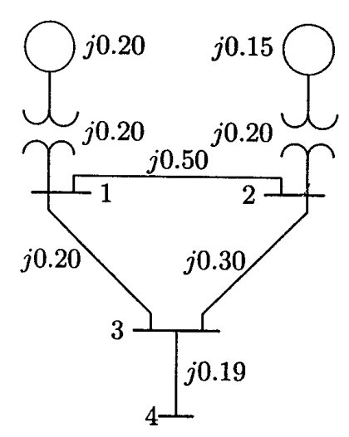
Figuer3: Fault Analysis problem 3
# Determine the fault current, the bus voltages, the bus voltages, and the line currents during the fault when a balanced three-phase fault with a fault impedance Zf=0.16 per unit occurs on.
Experimental data table:
At Z_{f} = 0.0 ohm
Number | Name | Phase Volt A | Phase Volt B | Phase Volt C | Phase Ang A | Phase Ang B | Phase Ang C
1 | BUS 1 | 0.6 | 0.6 | 0.6 | 0 | -120 | 120
2 | BUS 2 | 0.65 | 0.65 | 0.65 | 0 | -120 | 120
3 | BUS 3 | 0.38 | 0.38 | 0.38 | 0 | -120 | 120
4 | BUS 4 | 0 | 0 | 0 | 90 | 90 | 90

At Z_{f} = 0.0225 ohm
Number | Name | Phase Volt A | Phase Volt B | Phase Volt C | Phase Ang A | Phase Ang B | Phase Ang C
1 | BUS 1 | 0.60866 | 0.60866 | 0.60866 | 0 | -120 | 120
2 | BUS 2 | 0.64074 | 0.64074 | 0.64074 | 0 | -120 | 120
3 | BUS 3 | 0.38091 | 0.38091 | 0.38091 | 0 | -120 | 120
4 | BUS 4 | 0 | 0 | 0 | 0 | -116.57 | 116.57

Fault Current,Subtransient phase Current(p.u,deg):
